Promotions Standard to join Junior National:
- Attend 85% monthly, 6 out of 7 sessions a week, willingness to attend 7 from 7.
- Target SNAGs, continuous consideration into West Districts. Must make 1 national event from the following:
  - British Summer Championships/British Championships
  - SNAGs
  - Scottish Open Long Course
  - Scottish Open Short Course
  - Scottish Schools Finals
  - Scottish Summer Meet
- Good attitude- Ready (Fit), Willing (to improve), Consistent & Polite
- Willingness to make up missed sessions
- Motivated to keeping healthy, fit and competing at the highest level
- Consistently positive and determined within the training and competition environment
- Basic knowledge of goal setting
- Swim 100’s off a base time of 1.40
- Kick 50’s off a base time of 60 and pull 50’s off a base time of 55
- Have the ability to perform 2-3-2 around the wall when swimming Frontcrawl and produce 5 kicks off the wall when swimming Butterfly or Backstroke – This must be consistent and shown throughout all sessions and not just some.
- Disciplined throughout sessions on a daily basis, including land work.
- Focus on identifying key improvement areas personally and striving to develop these
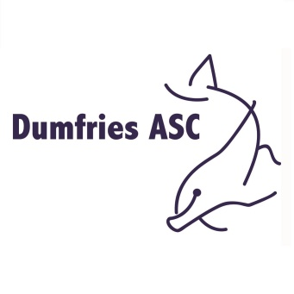
  - Consistent high quality technique over a progressively longer distance (all strokes)

