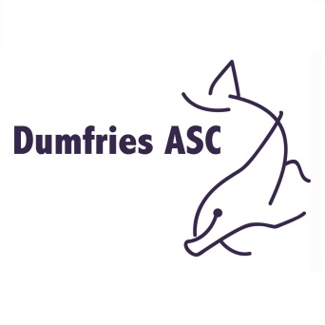

Equal Opportunities Policy
Dumfries ASC is committed to ensuring that equity is incorporated across all aspects of its development. In doing so it acknowledges and adopts the following definition of sports equity:
‘Equal opportunity in sport is about fairness, equality of access, recognising inequalities and taking steps to address them. It is about ensuring the culture and structure of sport is equally accessible to everyone in society.’
- Dumfries ASC respects the rights, dignity and worth of every person and will treat everyone equally within the context of their sport regardless of age, ability, gender, race, ethnicity, religious belief, sexuality or social / economic status.

- Dumfries ASC is totally committed to the principals and practice of equal opportunities as stated above across its training, coaching and competitive programme by all its members.

- Dumfries ASC is committed to everyone having the right to enjoy their sport in an environment free from threat of discrimination, intimidation, harassment and abuse.

- All club members have a responsibility to oppose discriminatory behaviour and promote equality of opportunity.

- Dumfries ASC will deal with any incidence of discriminatory behaviour seriously according to club disciplinary procedures and national governing body (Scottish Swimming) guidelines (see Section BL4.0 of club constitution)

Policy Statement issued by Management Group on behalf of
Dumfries ASC

